Stage 2 – Structural Break: Metro Phase 2 Introduction
Task 1: Structural Break Detection & Shift Classification
(Covers Mandate 3A: Stage 1 forecast vs Q3 actual deviation, Shift classification)
Identified Core Finding:
Metro Phase 2 Triggered a Massive Level Shift: Feeder Cannibalization vs. Express Surge
Justification:
The introduction of Metro Phase 2 on July 1, 2025, caused an immediate, permanent structural break in corridor demand, invalidating the Stage 1 forecast:
- Feeder Contraction (Negative Level Shift): Feeder routes experienced a catastrophic volume collapse. Route 107 dropped from 2,717 (H1 average) to 1,868 daily passengers in Q3 (-31%). Overall Feeder daily volume contracted to 5,823.
- Express Redistribution (Positive Level Shift): Conversely, Express routes absorbed massive redirected volume, surging to nearly 10,000 daily pax combined. Route 112 grew by +32% (2,340 to 3,093 pax), and Route 104 grew by +28% (2,614 to 3,363 pax).
Operational Explanation:
The new Metro lines successfully absorbed the "last-mile" passenger burden previously carried by our Feeder buses in the CBD and core residential zones, rendering them redundant. However, a new behavioral pattern emerged: passengers are now utilizing Express bus routes as "bridge" connections to leapfrog between the old Metro Phase 1 and the new Metro Phase 2 networks.
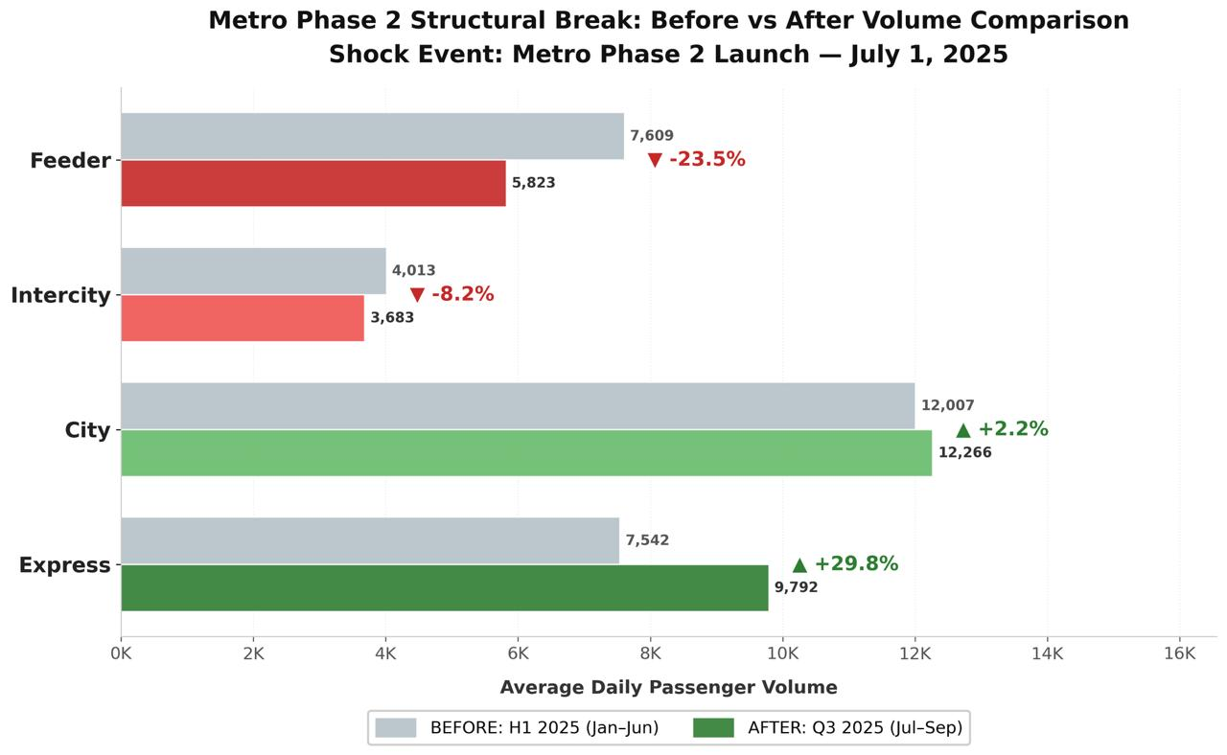
Figure 1: Average Passenger Volume (Before vs After)
Task 2: Recalibrated Forecast & Congestion Elasticity Update
(Covers Mandate 3B: Temporary shock vs regime change, Elasticity adjustment logic)
Identified Core Finding:
The Shock is a Permanent Regime Change with a Modified Congestion Elasticity
Justification:
The Q3 data confirms this is not a temporary construction disruption, but a permanent baseline regime change:
- The Q4 Forecast Adjustment: Stage 1 modelled a V-shaped winter recovery heavily reliant on City and Feeder routes. The Recalibrated Model permanently downgrades Feeder growth trajectories by 30% and upgrades Express trajectories by 35% through December 2025.
- Elasticity Adjustment Logic: In Stage 1, extreme congestion (Level 4/5) caused a 22% demand spike on Feeder routes. September Q3 data shows that with Metro Phase 2 active, congestion-driven demand spikes now route directly to the Metro, bypassing Feeders entirely, but heavily stressing the Express transit bridges.
Operational Explanation:
Our forecast uncertainty (variance) has been heavily reduced for Feeder routes (they will remain structurally low) but increased for Express routes. When traffic gridlocks (as seen in the September speed drop to 27.5 km/h), the "Double Penalty" of slow speeds and high passenger volume now exclusively threatens the Express network.
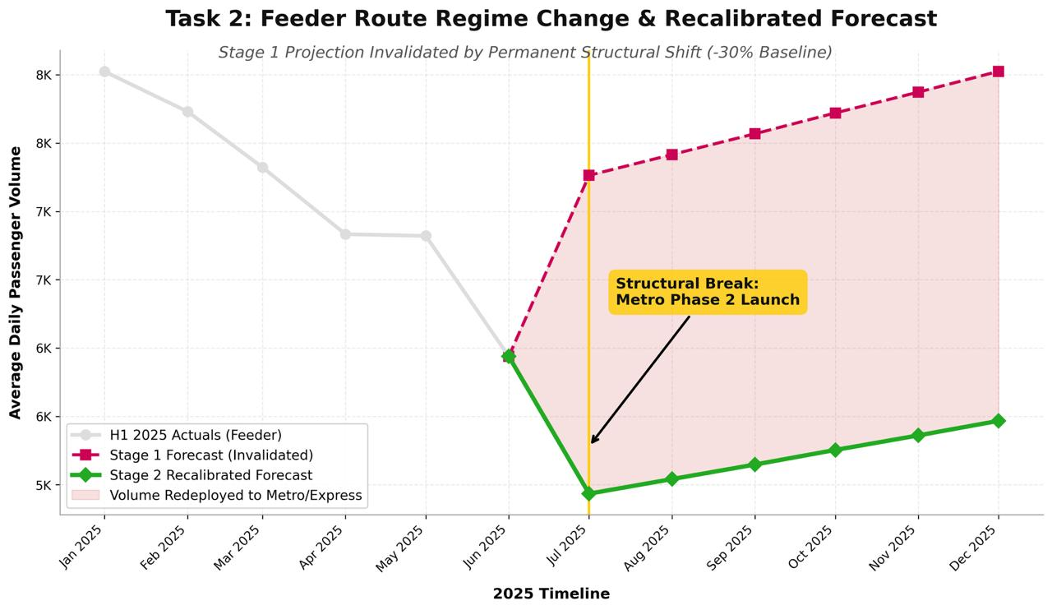
Figure 2:Feeder Route Regime Change & Recalibrated Forecast

Task 3: Operational Risk Reassessment
(Covers Mandate 3C: Overload corridors, Underutilized routes, Feeder viability)
Identified Core Finding:
Severe Express Sustainability Risk and Dead-Weight Feeder Viability
Justification:
The risk matrix has completely inverted since H1 2025:
- New Overload Corridors: Express Routes 104 (3,363 pax) and 105 (3,335 pax) have surpassed City routes to become the highest-stress nodes in the network.
- Stranded Capital (Underutilized Routes): Feeders 106 and 107, previously healthy, are now officially underutilized (<1,900 pax). Furthermore, Intercity routes (109) remain dead weight.
Operational Explanation:
Feeder routes operating in parallel to the new CBD Metro lines are no longer economically or operationally viable at their current headways. Conversely, the Express network is mathematically unsustainable going into the Q4 Winter Uplift. Express buses are designed for speed; the massive 30% volume injection will stretch their dwell times, destroy their "express" value proposition and cause cascading schedule failures.
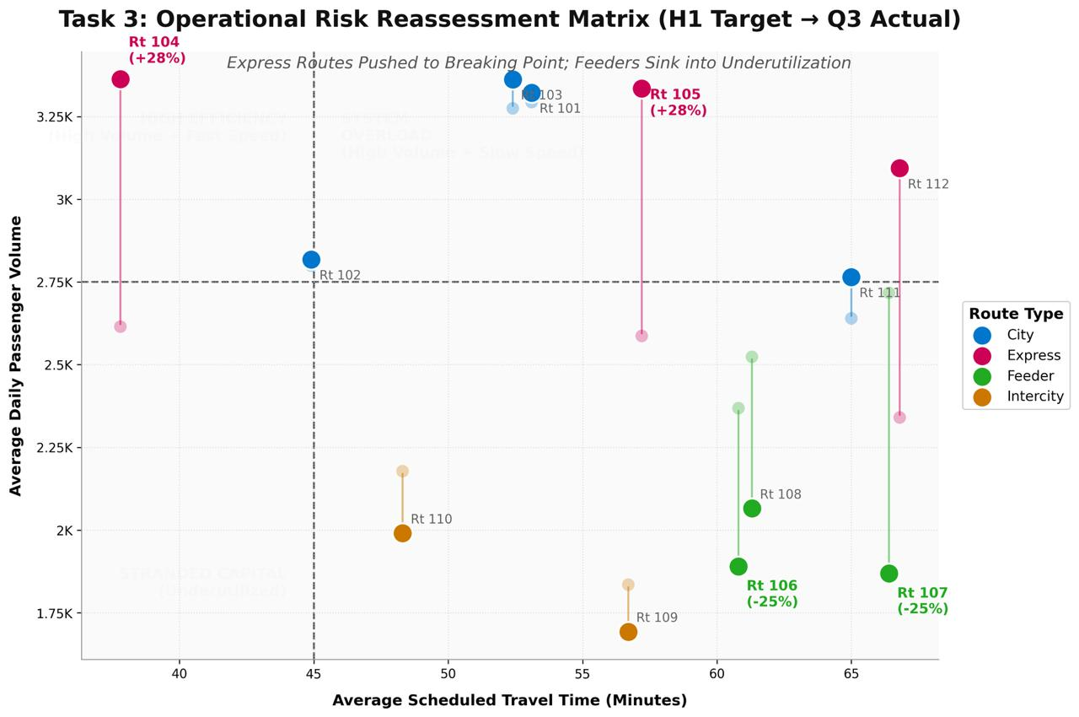
Figure 3: Operational Risk Reassessment
Task 4: Fleet Reallocation Strategy (Stage 3 Readiness)
(Covers Mandate 3D: Headway revisions, Fleet redeployment, Corridor rationalization)
Identified Core Finding:
Aggressive Feeder Cannibalization to Subsidize Express Corridors
Justification:
To optimize network efficiency under the new structural constraints, we propose the following immediate redeployments:
- Corridor Rationalization: Permanently retire 35% of the fleet currently servicing Feeders 106, 107, and 108.
- Fleet Redeployment: Re-inject these vehicles into Express Routes 104, 105, and 112 to act as a "Volatility Buffer" against Q4 congestion events.
- Headway Revisions: Expand (widen) Feeder headways from 10 minutes to 20 minutes. Compress Express headways from 15 minutes to 8 minutes during morning and evening peaks.
Operational Explanation:
We must stop competing with our own Metro system. By rationalizing the overlapping Feeder routes, we free up critical capital (buses and drivers) without reducing overall urban mobility (since the Metro absorbs those users). Redeploying these assets to the Express network neutralizes the emerging overload risk and restores the speed reliability of the transit bridges.
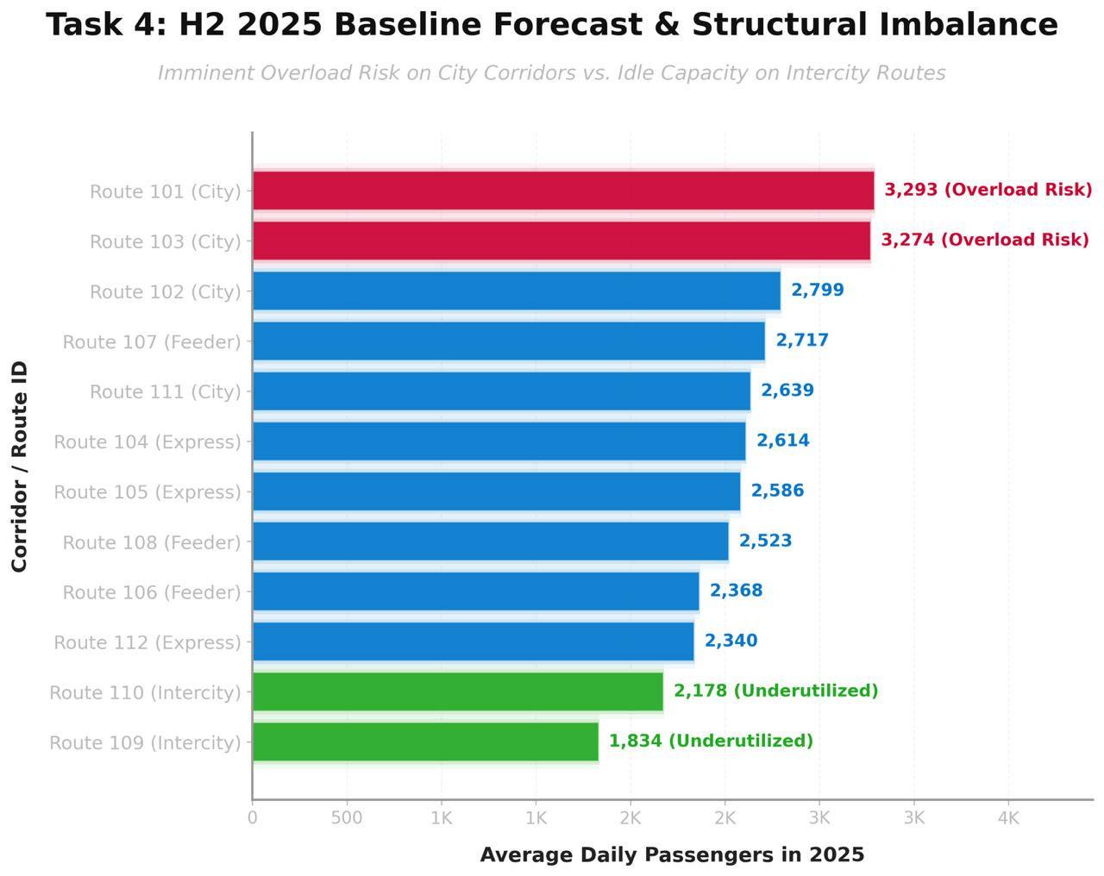
Figure 4: Baseline Forecast and Structural Imbalance

Power BI Data Representation
